At Home Practice

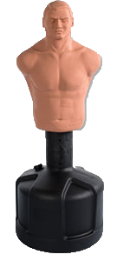

Versys Spar 1 $199\*

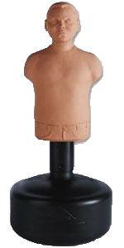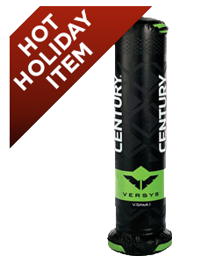

B.O.B. / Bobby $259/279\*

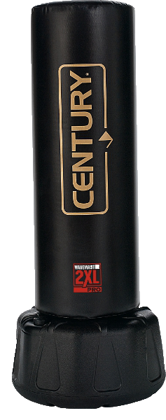

Wavemaster $149\*

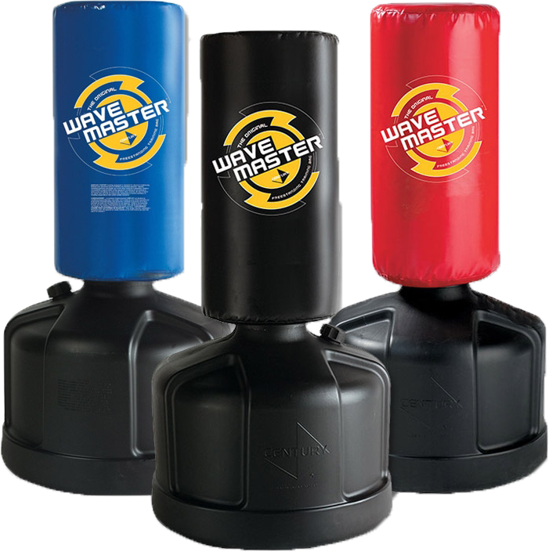

Wavemaster 2XL $399\*

*\*Ask About Our Easy Pay Option - Available on any Wavemaster*