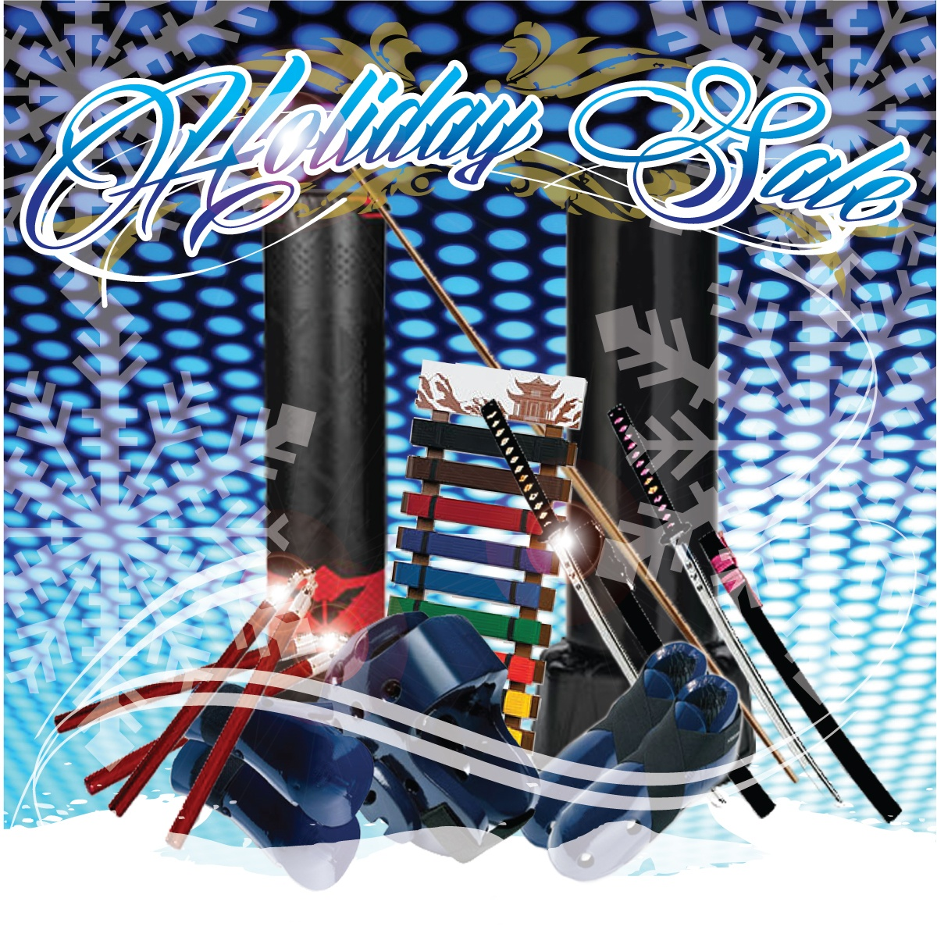Gear & Gear Packs

Basic Gear

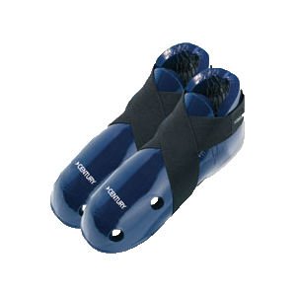

$37.99 $29.99 $29.99 $43.99 $27.99

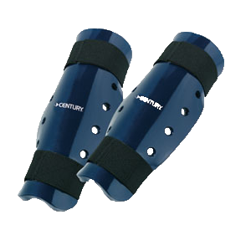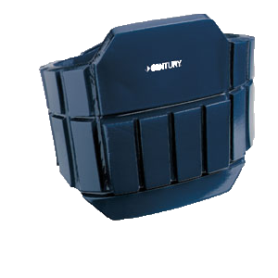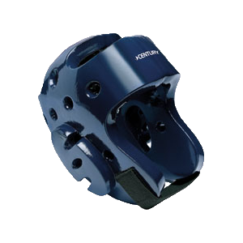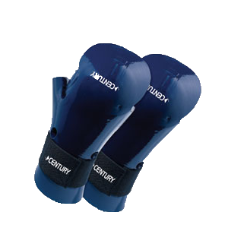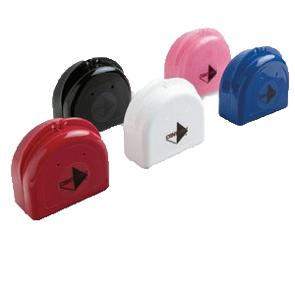

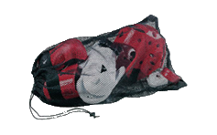Basic Package $189

Mouthpiece $2

Mouthpiece Case $4

Cup & Supporter $14

Includes all Basic Gear plus a

*Free Mesh Bag*

P2 Gear

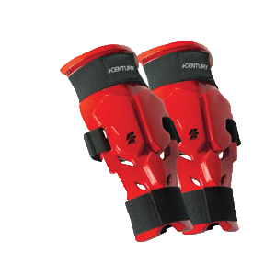

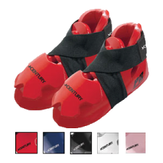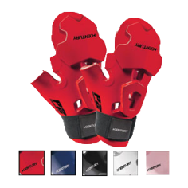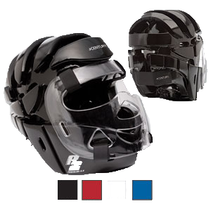 $99.99 $39.99 $39.99 $64.99 $39.99

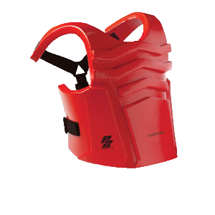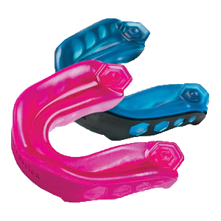

Pro Package $349.99

Shock Doctor

Mouthpeice

$19.99

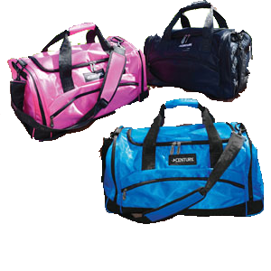

Includes full P2 Gear set

Shock Dr. Mouthpiece

Century Gear Bag

Century Gear

Bag $44.99/49.99