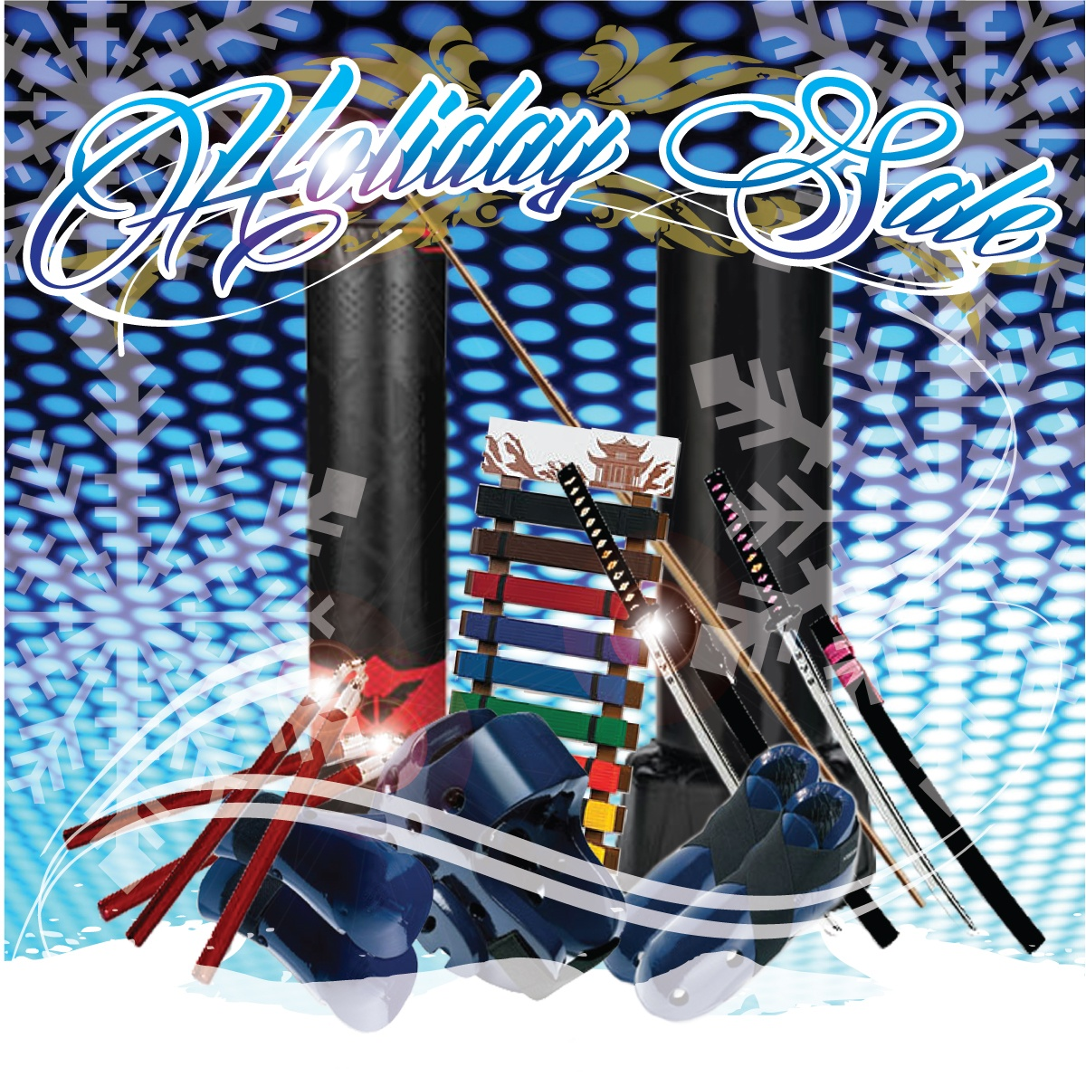
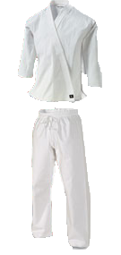Uniforms

Ninja Gi $3999

Prep Program Gi $3999
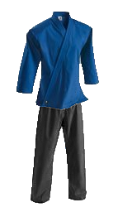

Leadership Gi $6499

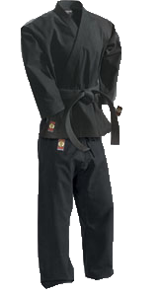
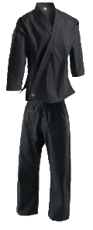 10oz. Black Belt $8999

14oz. IronMan Gi $14999

*BBLP/Black Belt/IronMan Gis are custom order and take a minimum of 3 weeks from time of purchase to be delivered

